AdvWAF-v14.x Updates

Lab Guide

Participant Hands-on Lab Guide



Last Updated: *7/16/15*

©2015 F5 Networks, Inc. All rights reserved. F5, F5 Networks, and the F5 logo are trademarks of F5 Networks, Inc. in the U.S. and in certain other countries. Other F5 trademarks are identified at f5.com.

Any other products, services, or company names referenced herein may be trademarks of their respective owners with no endorsement or affiliation, express or implied, claimed by F5.

**Table of Contents**

Lab Network Overview 2

Accessing the lab environment 4

Exercise 1 – ASM Policy Creation and Logging 6

Create ASM Policy 6

Creating Application Security Policy 7

Enable Application Security Logging 9

Exercise 2 – Policy Staging 14

Understanding Staging 14

Perform a SQL Injection 14

Perform a Cross Site Scripting attack 16

Signature Staging 18

Exercise 3 - Mitigating BoT Attacks 22

Mitigating Bots using a Bot profile (v14.1) 22

Set up the Bot profile 22

Create a BoT Logging profile 23

Add the BoT profile to a virtual server 24

Attack with BoTs and observe the results 24

Exercise 4 – Protecting Credentials with DataSafe 28

Exercise 1 – Review and Attack the Login Page 28

Task 1 – Review Form Fields with the Developer Tools 28

Task 2 – Review Methods for Stealing Credentials 28

Task 3 – Perform a Form Field “Web Inject” 29

Exercise 2 – Review and Configure DataSafe Components 31

Task 1 – DataSafe Licensing and Provisioning 31

Exercise 3 – Testing DataSafe Protection 33

Task 1 – Review the Protected Hackazon Login Page 33

Lab Network Overview

Each student will have a BIG-IP VE environment with IP addressing as below:

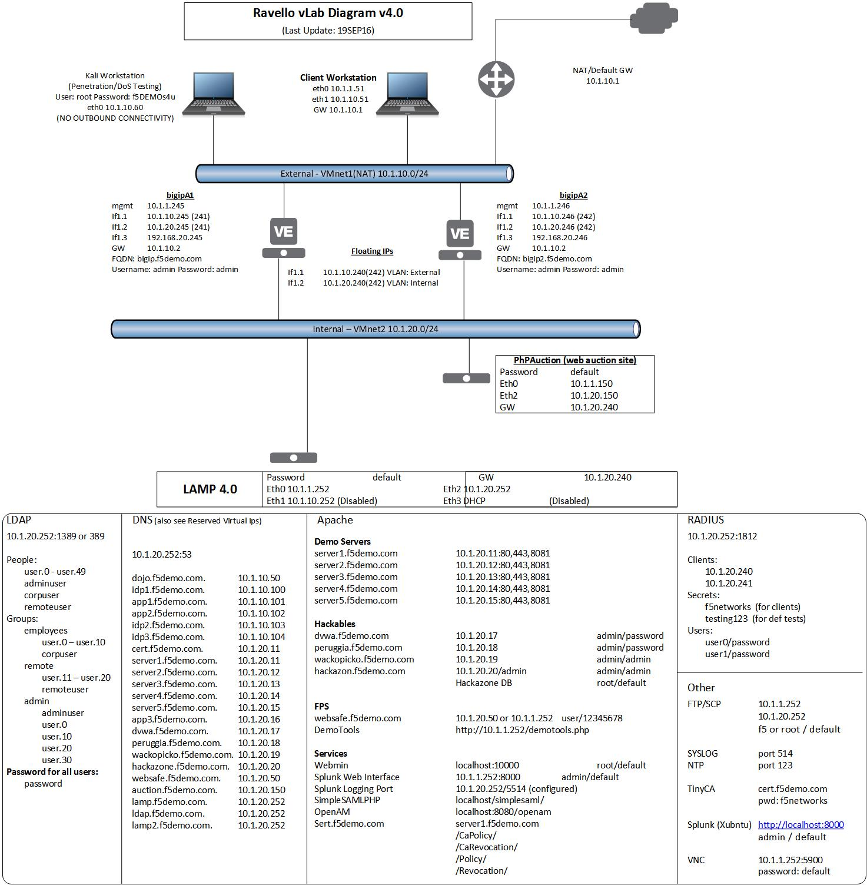

Accessing the lab environment

* 1. Open a browser and go to the link assign to you b (where **X** is your student number)
  2. Look for the **xubuntu-jumpbox-vxx**. You will use the xubuntu jumpbox for all the labs. (see below)

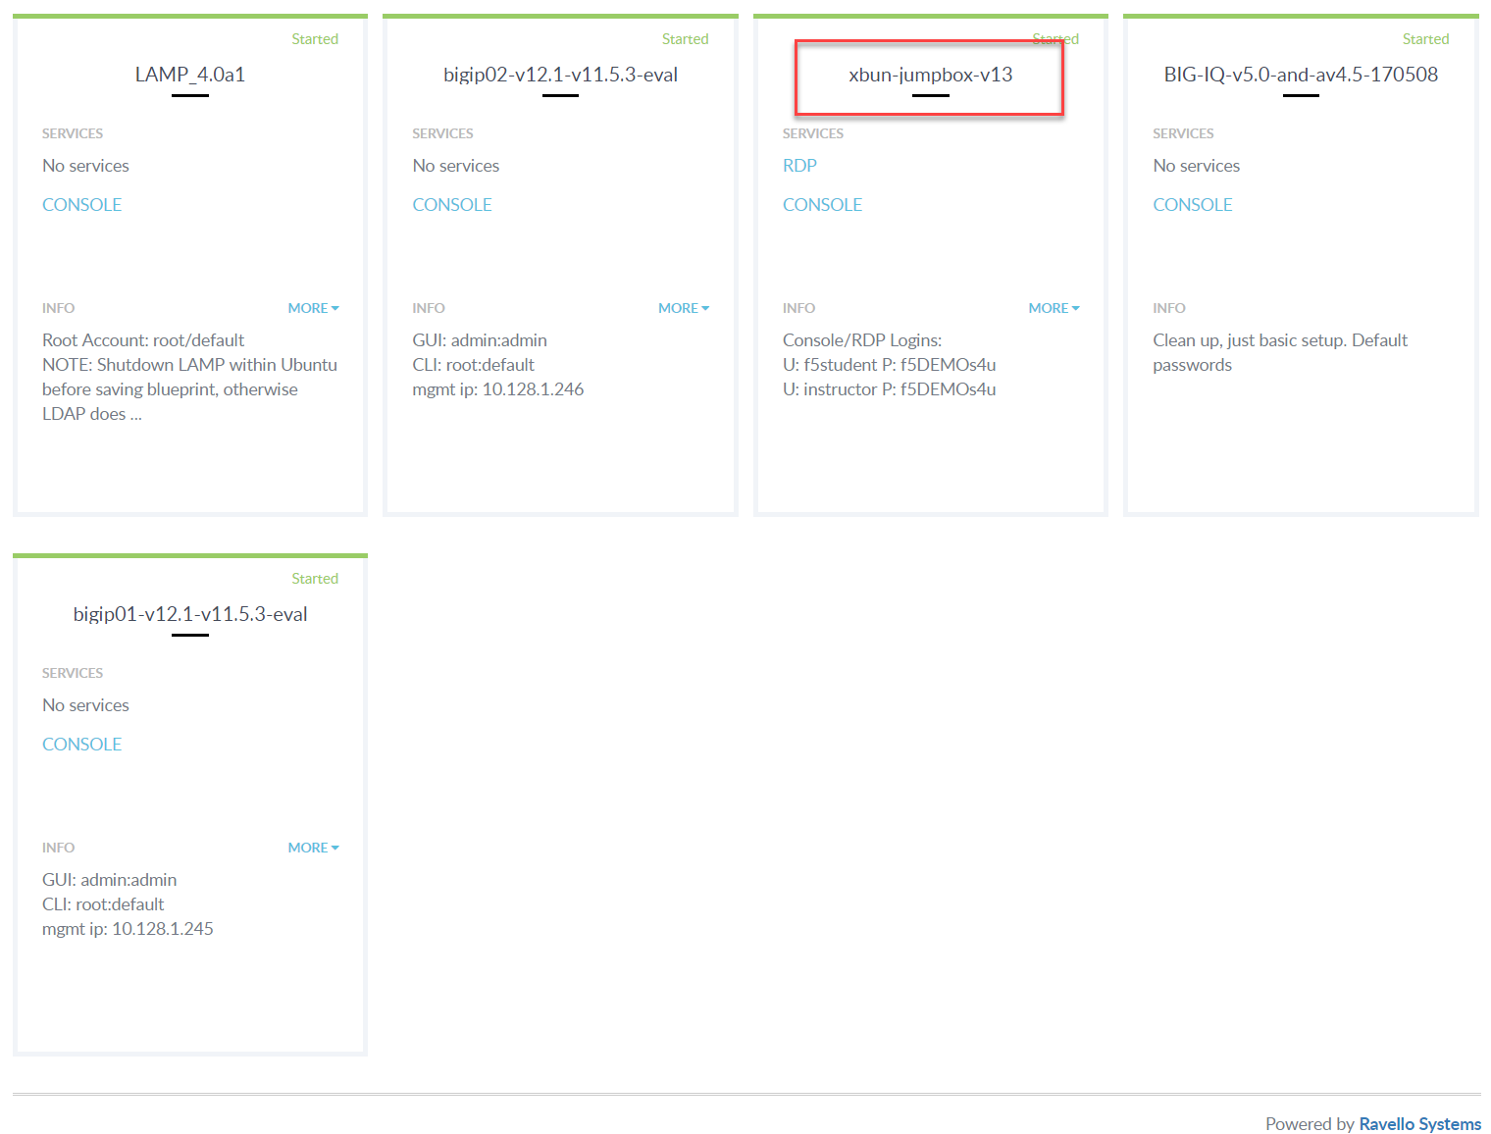

* 1. You can click on **RDP** to RDP to the Xubuntu jumpbox or you can select the **CONSOLE** link and access the jumpbox via your browser. **The CONSOLE link requires you turn off pop-up blockers.**

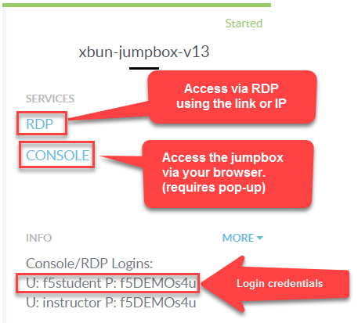

1. Open the Chrome browser and log into the BIG-IP GUI to verify the BIG-IP is up.
   1. Go to **https://10.1.1.245**
      1. User: **admin**
      2. Password: **admin**
2. Now you will perform an initial configuration via command line.
   1. Open a terminal window from the taskbar at the bottom.
      1. Log in to the BIG-IP using the command: **ssh root@10.1.1.245**
      2. The password is **default.**
      3. At the BIG-IP prompt, enter **tmsh**
         1. This will place you in the BIG-IP command line mode.
   2. In your browser, open then the **Lab Guides** link on the bookmarks bar in a new tab/window.
   3. Open the **AdvWAF Base Setup.txt** file and review the commands.
   4. Copy all the commands between **# BEGIN COPY - Lab prep** and **# END COPY - Lab prep**
   5. Paste the commands into the terminal window at the **tmsh** prompt.
   6. **The BIG-IP will take several minutes to come back online.**
      1. Good time for a bathroom break. Smoke ‘em if you got ‘em.
3. Verify the virtual server and web site are up and running.
   1. Go to **Local Traffic >> Network Map**. There should be two virtual servers and all should be available (green).
   2. Open up the Firefox browser. Go to <http://hackazon.f5demo.com> and <https://hackazon.f5demo.com>

Exercise 1 – ASM Policy Creation and Logging

Create ASM Policy

Objectives:

* View the v14.x policy building GUI interface
* Create a security policy using automatic policy building
* Enable application security logging profile
* Estimated time for completion: **20 minutes**

This lab will demonstrate how to create and build a security policy using automatic policy building.

Before you begin, the penetration testing tool, OWASP ZAP, has already been run against the website and the results have been saved. Let’s take a look at the test to see the results. You will use this information to plug a few holes.

1. From the Applications Menu in the upper left-hand corner of the jumpbox go to **OWASP > Proxies > ZAP**.
2. Once ZAP is open, click on **Start** when asked Do you want to persist the ZAP session.
3. Under **File** select **Open Session** and select **hackazon-zap-session.session.**
4. Once the session is loaded, go to the **Alerts** tab, you will see a number of vulnerabilities found.

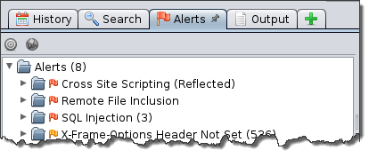

* 1. We will be focusing on the CrossSite Scripting (XSS) and SQL Injection vulnerabilities discovered specifically, on the Search page and User Login page.
     1. If you expand the tabs you can see the vulnerabilities found. Click on the page to get more detail.

Creating Application Security Policy

1. **Guide Configurations** is only available for Advanced WAF, so we will build our policies using the Create New Policy wizard.
2. On the Main tab, click Security > Application Security > Security Policies. The Active Policies screen opens.
3. Click the Create.. button. As you can see, security policy setup is done on a single page.

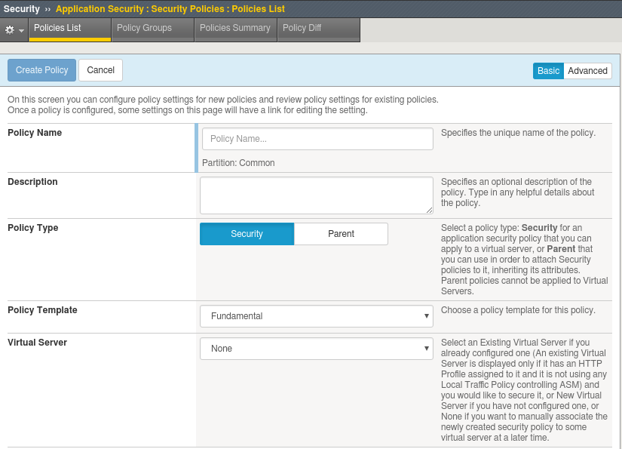

1. Enter the following information:
   1. Name: **hackazon_asm**
   2. Policy Type: **Security**
   3. Policy Template: **Comprehensive**
   4. Virtual Server: **vs_hackazon_http (HTTP)**

If you are familiar with pre 13.x ASM you may have noted there is no longer an “Enhanced” policy selection. Also, if you look in the upper right-hand corner you will see **Basic** and **Advance** selections.

1. Select **Advanced** and read the descriptions of the configuration items and modify the following configuration items.:
   1. Application Language: **Unicode (utf-8)**
   2. Enforcement Mode: **Transparent**
   3. Server Technologies: <Select **Apache Tomcat**, **MySQL**, **Unix/Linux**>
   4. Trusted IP: **10.1.10.0/255.255.255.0**
   5. Policy Builder Learning Speed: **Fast**

If you recall, **Server Technologies** assigns attack signatures base on the selected technologies, but can also learn new technologies based on HTTP Requests/Responses. The Hackazon website user PHP, which you did not enter. Later you will see if BIG-IP discovers PHP and adds the attack signatures.

You also made your jumpbox a “trusted” client and set the learning speed to fast, so the policy will build quickly.

When you are done your **Advance** configuration items should look something like this:

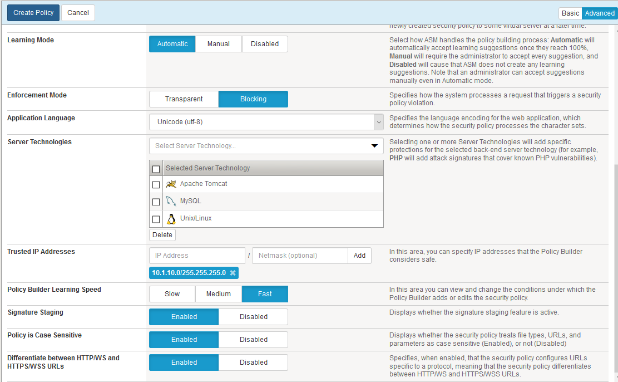

1. Review your security policy and click **Create Policy** at the upper left. It may take a few minutes. Notice you have a number of new things you can do with your security policy.

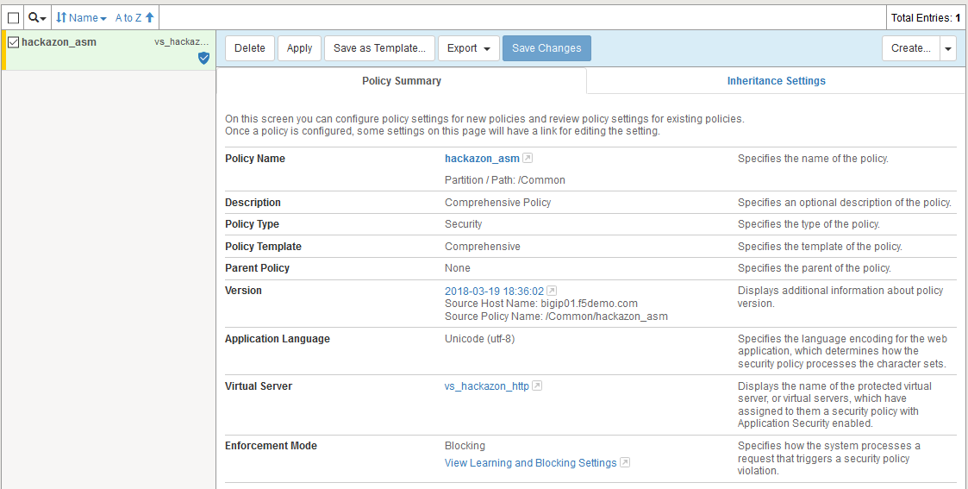

Enable Application Security Logging

1. In the Configuration Utility, open the **Security > Event Logs: Logging Profiles** then click **Create.** Enter a Profile Name **asm_allrequests**, select the checkbox for **Application Security,** change the **Configuration** dropdown to **Advanced**, and then set the **Response Logging** dropdown to **For All Requests.** Change the **Request Type** under storage filter to **All Requests.** Click **Finished.** Be aware logging all responses will put additional load on the BIG-IP.

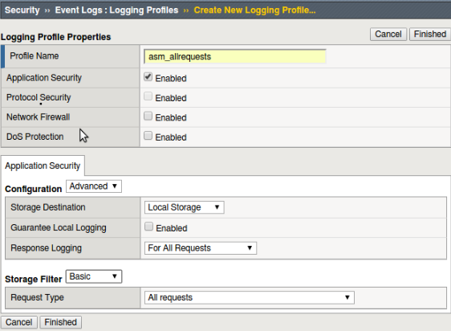

1. In the Configuration Utility, open the **Local Traffic > Virtual Servers.** Select **vs_hackazon_http** and click the **Security > Policies.** Change the **Log Profile** option to **Enabled** and then move the **asm_allrequests** from Available to Selected and click **Update**.

Note that the Application Security Policy has already been applied per the wizard.

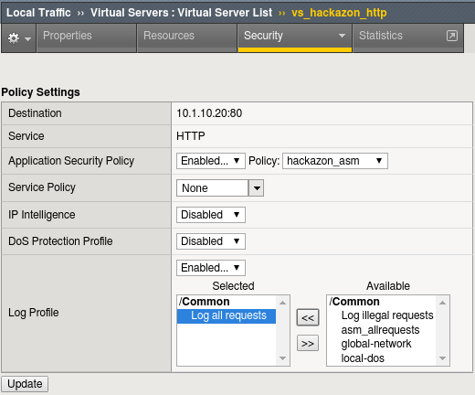

1. Generate trusted learning suggestions by browsing the Auction site via the protected virtual server.
   1. Use the **Firefox** browser to access [**http://hackazon.f5demo.com**](http://hackazon.f5demo.com)
   2. Select **Sign In** in the upper right corner and attempt to login to the site using guessed credentials of **student/student** and submit them with the **Sign In** button. The login will fail, but will generate learning suggestions which is all we are looking for at this time..

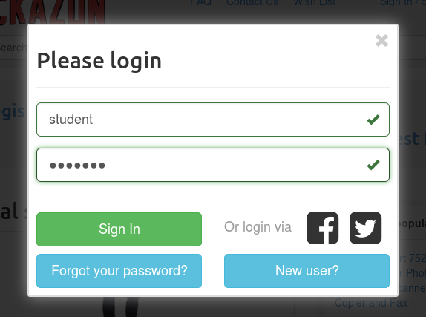

* 1. In the Configuration Utility, open the **Security > Application Security > Policy > Audit > Log** page and you’ll notice that as a result of interaction with the web site, elements are being added to the Policy by the Policy Builder as the ASM is learns the application. It may take a minute or so for all the elements to show. Since the requests came from a trusted device, you can click the “**Apply Policy**” button if “**Changes have not been applied yet**” is displayed.

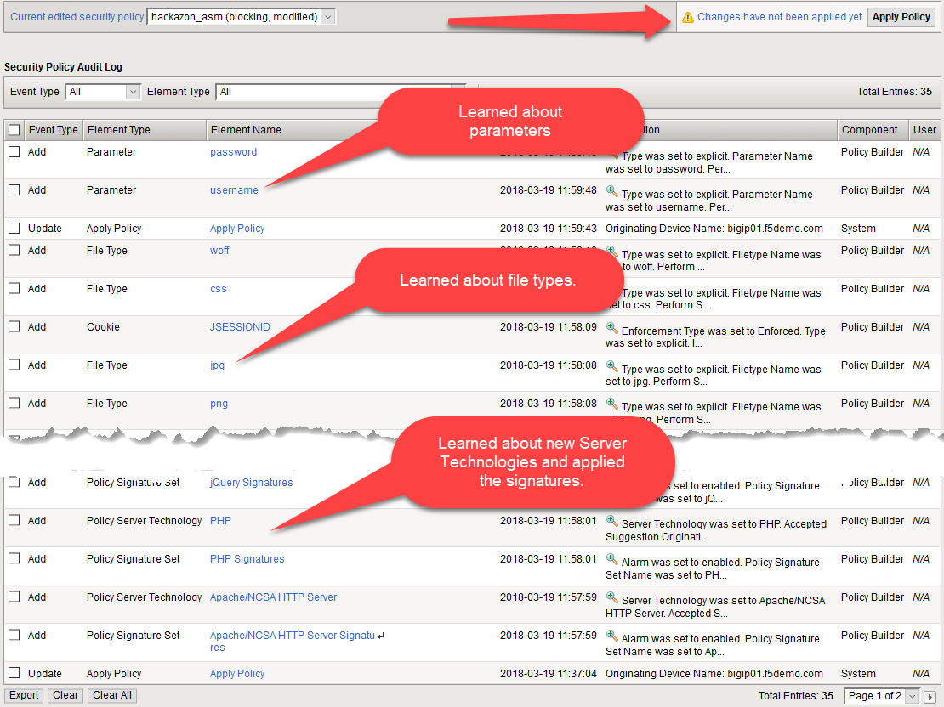

* 1. Return to the Hackazon using a private browser window, select **Sign In** and re-attempt a login to the site using **verylong.username@example.com/pa$$wordwithspecia!s**
  2. Return to the **Security > Application Security > Policy > Audit > Log** page in the F5 Configuration Utility and notice that further updates have been made to the Policy. Click the “**Apply Policy**” button if “**Changes have not been applied yet**” is displayed

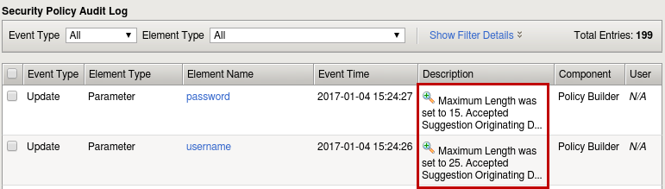

* 1. The login form has now been “learned” by the Policy Builder and added to the policy.

1. In the Configuration Utility, open the **Security > Application Security > Traffic Learning** page. You will see that this page has change a lot and has consolidated a lot of information, such as the learned entities. Review this page.

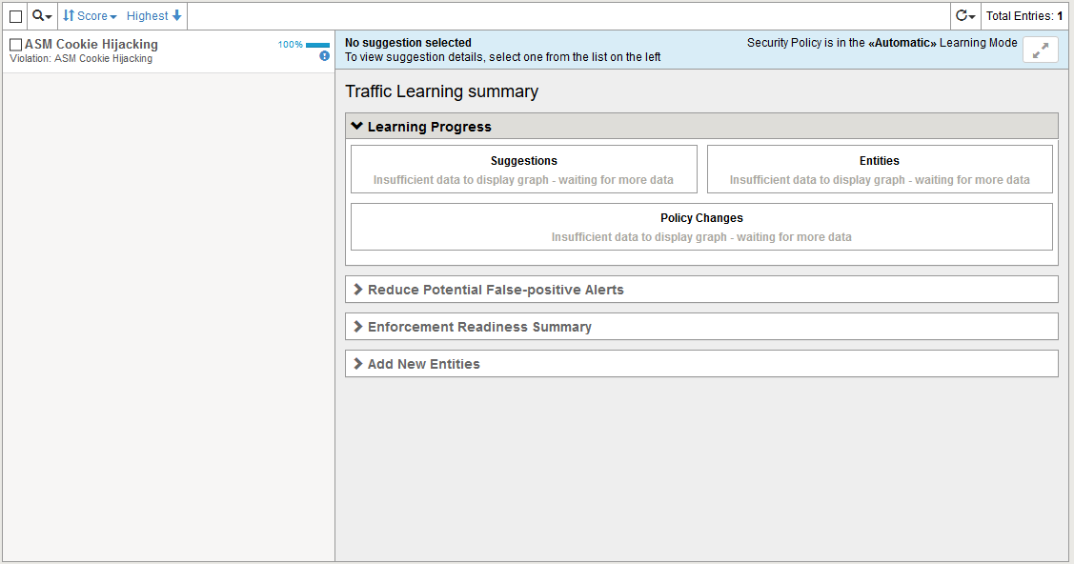

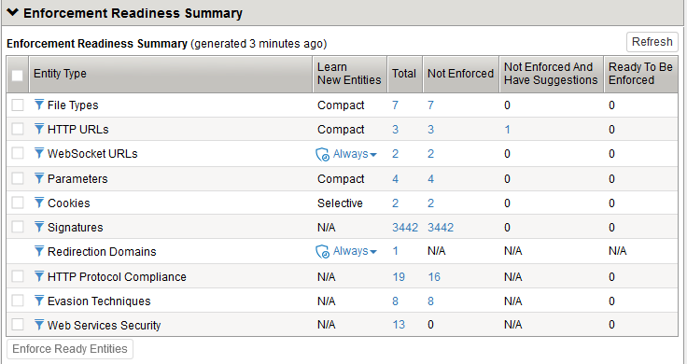

1. Under the **Entity Type** column in the **Parameter** row click on the **Total** number and you will see the parameters you discovered. Select a parameter and you will see how the parameter is configured. Note the maximum length that was set after you put in a long username and password.
2. Open **Security->Event Logs->Application->Requests.** Under **Requests Lists** remove the **Illegal Request** filter by clicking the **X.** You should see log entries with recent timestamps. Look for the **/user/login** entry with the violation rating. Note the violation and reason **Illegal parameter value length**. That is because the initial length was set to 10 as the BIG-IP was learning. Note the username and password at the bottom of the decoded request. BIG-IP does not reveal sensitive parameters in the log files.

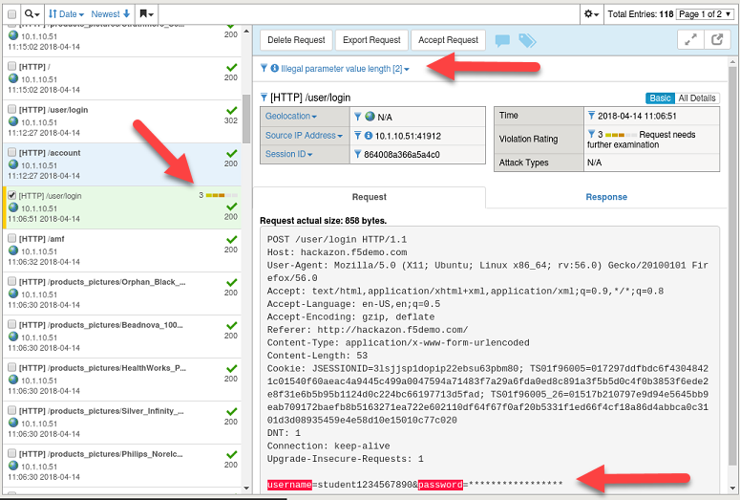

1. A policy change be modified at any time and there are numerous additional settings in the **Advanced** menu. In the Configuration Utility, open the **Security->Application Security->Policy Building > Learning and Blocking Settings**. Make sure the **Advanced** view option is selected.

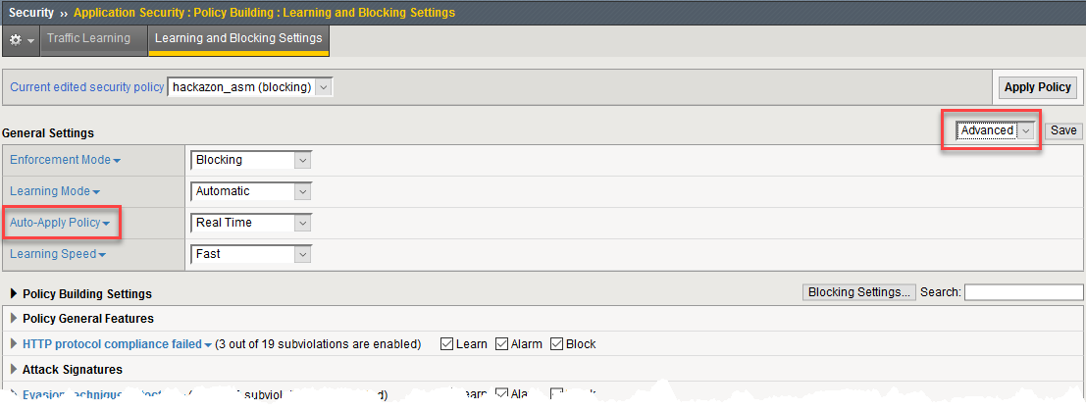

Click **Auto-Apply Policy** (the name, not drop-down) to get a description of the configuration item.

1. You are now finished building the policy for this exercise. You need to set the **Enforcement Mode** to **Blocking** and you need to remove the client network from the trusted IP addresses so that you can attempt to attack the Auction Website from your client PC. From the **Policy Building Process** section select the **Trusted IP Addresses** link and remove the 10.1.10.0/24 entry from the **IP Address Exceptions List.**

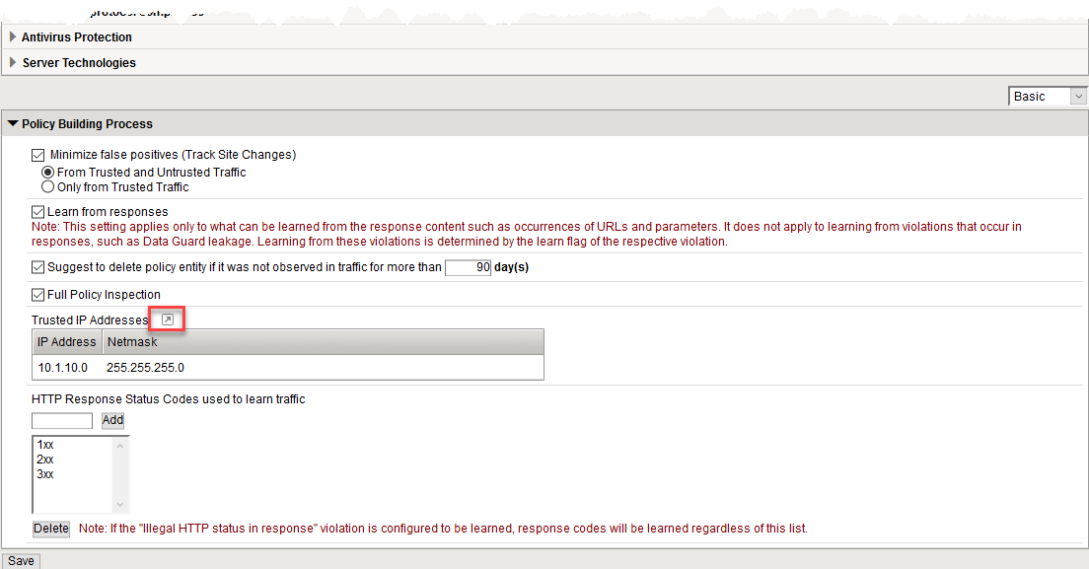

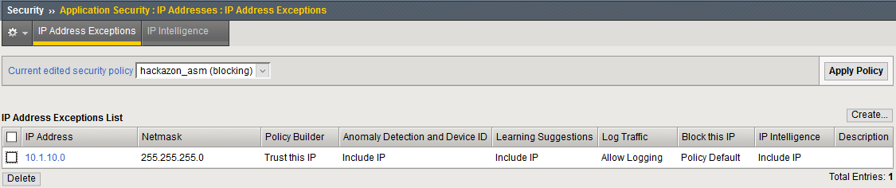

1. At the top of the page, click the **Apply Policy** button to apply your changes.

Exercise 2 – Policy Staging

Objectives:

* Demonstrate SQL Injection
* Demonstrate Forceful Browsing
* Signature staging behavior
* Estimated time for completion: **20 minutes**

Understanding Staging

If you look at the OWASP ZAP session you opened earlier you will see the ZAP detected a potential SQL Injection vulnerability.

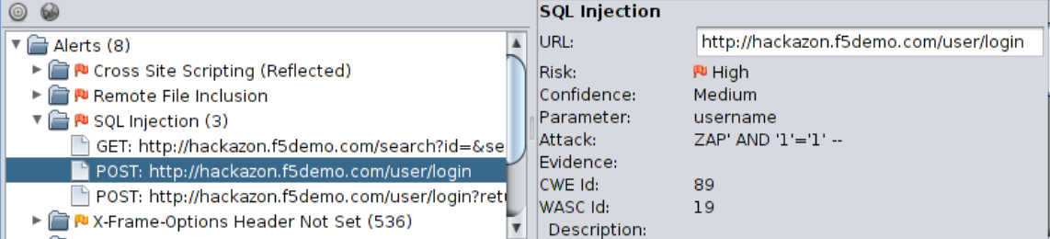

What this indicates is the username parameter will process the metacharacters that can be used to craft a successful attack. You are going to plug that hole.

Perform a SQL Injection

1. Close your last Firefox browser to the Hackazon site and open **new** FireFox browser to <http://hackazon.f5demo.com> and select **Sign In** in the upper right corner of the page.
2. Enter ZAP' AND '1'='1'in the **Username** section and anything you want for the password.

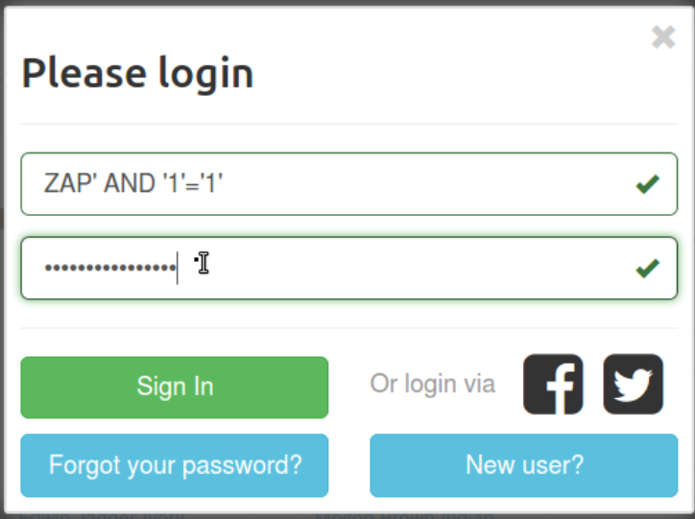

1. You will get a 503 Service Temporarily Unavailable response. This means your SQL injection got through and web server returned an error trying to process the request. This tells a hacker that if he can correctly craft the attack he will probably get through.
2. In the Configuration Utility, open the **Security->Event Logs->Application->Requests**. Remove the **Illegal Requests** filter.Click on the entry that contains ***[HTTP] /user/login*** with a ***503*** *response code (It will be the request in the list with a violation rating)*

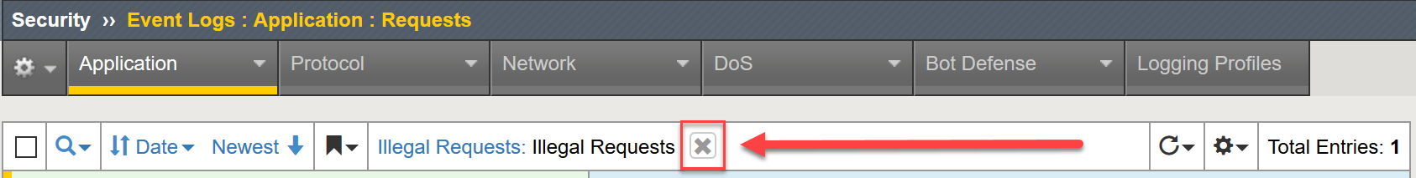

Click on the violations and you will notice t multiple signatures match this request and we can see these attack signatures are currently in staging.

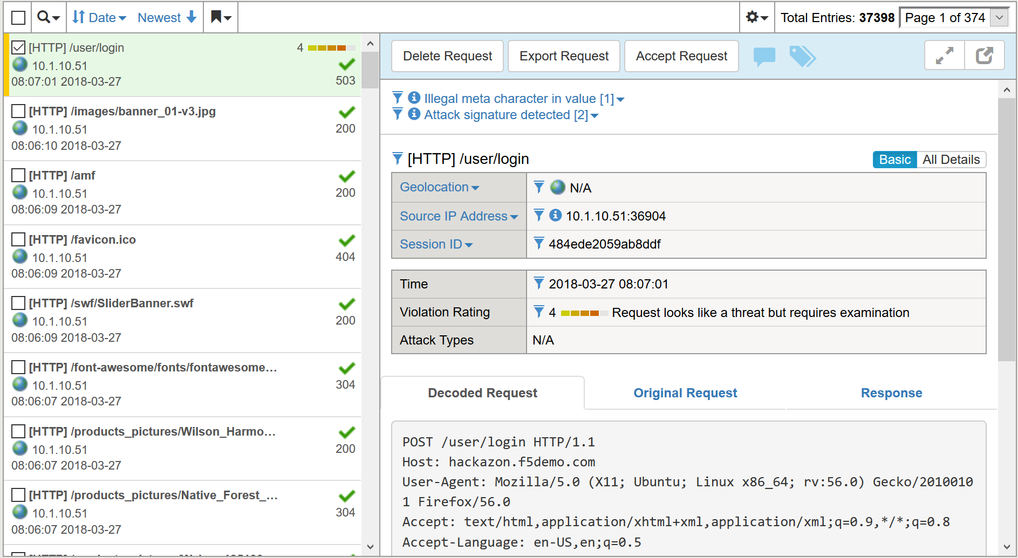

1. Click on the **Violation** and you will the BIG-IP suspects an SQL Injection attack, click on the **Occurrences** you will see the signature is in **Staging**. If in **Blocking** mode, this means the attack is logged but not blocked until the staging period is complete. Explore the page further for additional information. If you are in **Transparent** mode, blocking will never occur, regardless of the staging settings.

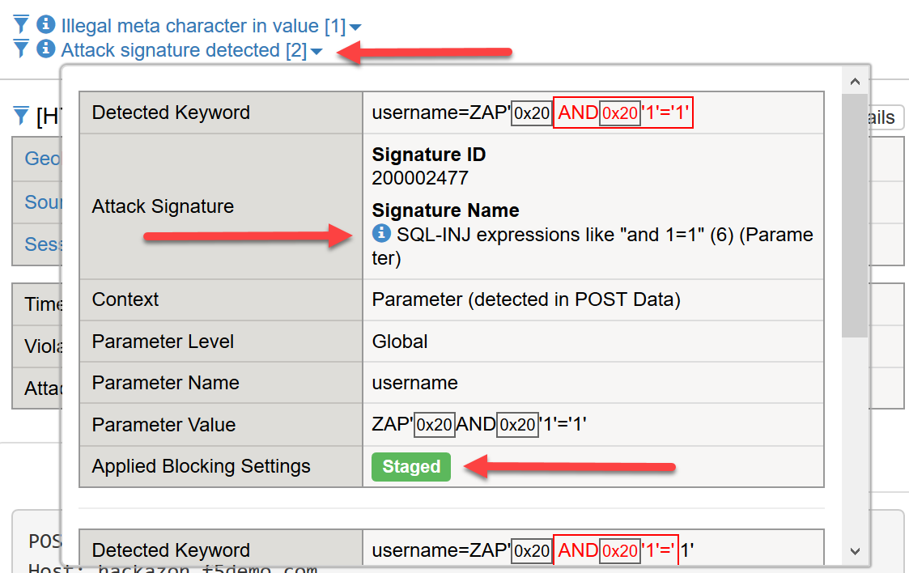

Perform a Cross Site Scripting attack

Again, if you look at the OWASP ZAP Alerts under **Cross Site Scripting (Reflected)** from the scanning section you will see there was a successful Cross Site Scripting attack against the search page. You can perform the attack by:

Entering the following into the search box:

<script>alert(1);</script>

Entering the following into the URL: http://hackazon.f5demo.com/search?id=&searchString=%22%3Cscript%3Ealert%281%29%3B%3C%2Fscript%3E%22

**Note:** This attack uses URL encoding in the XSS attack script.

1. Open the Firefox browser and access [**http://hackazon.f5demo.com**](http://hackazon.f5demo.com) virtual server.

**NOTE: IF your browser is already open, close it and open a new browser window.**

1. Past in the URL above or copy and paste the URL from the OWASP ZAP alert. You should get a pop-up indicating the attack was successful.
2. In the Configuration Utility, open the **Security->Event Logs->Application->Requests.**  Check all request by deleting the illegal request filter. You will see several new violations. Click on the entry that contains ***[HTTP] /search.***

You will notice several signatures detected. Explore the signatures, but also take a look at the **Original Request** and the **Decoded Request**. You will notice the BIG-IP normalized the request to match against the signatures.

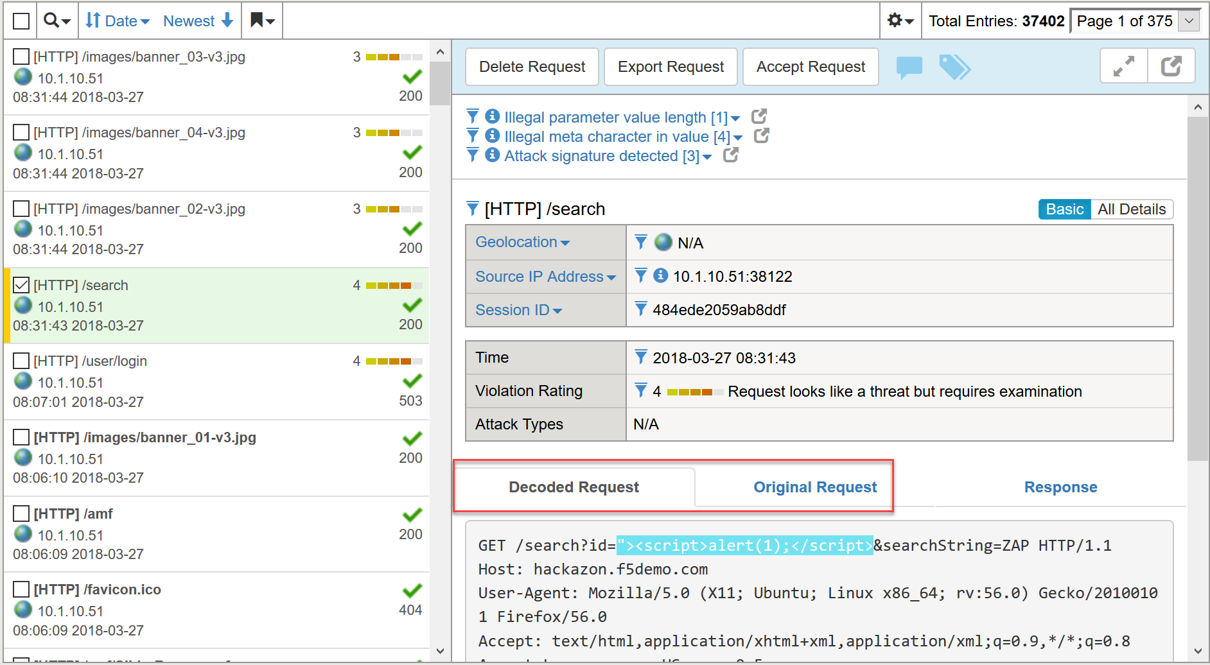

Signature Staging

1. In the Configuration Utility, open the **Security > Application Security > Policy Building > Learning and Blocking Settings.** Notice the **Enforcement Mode**. Because enforcement is set to **Blocking** once **Staging** is complete or removed, violations will be blocked. Under the **Policy Building Settings** section, expand the **Attack Signatures** section**.**  Uncheck **Enable Signature Staging** and click **Save** and **Apply Policy.**

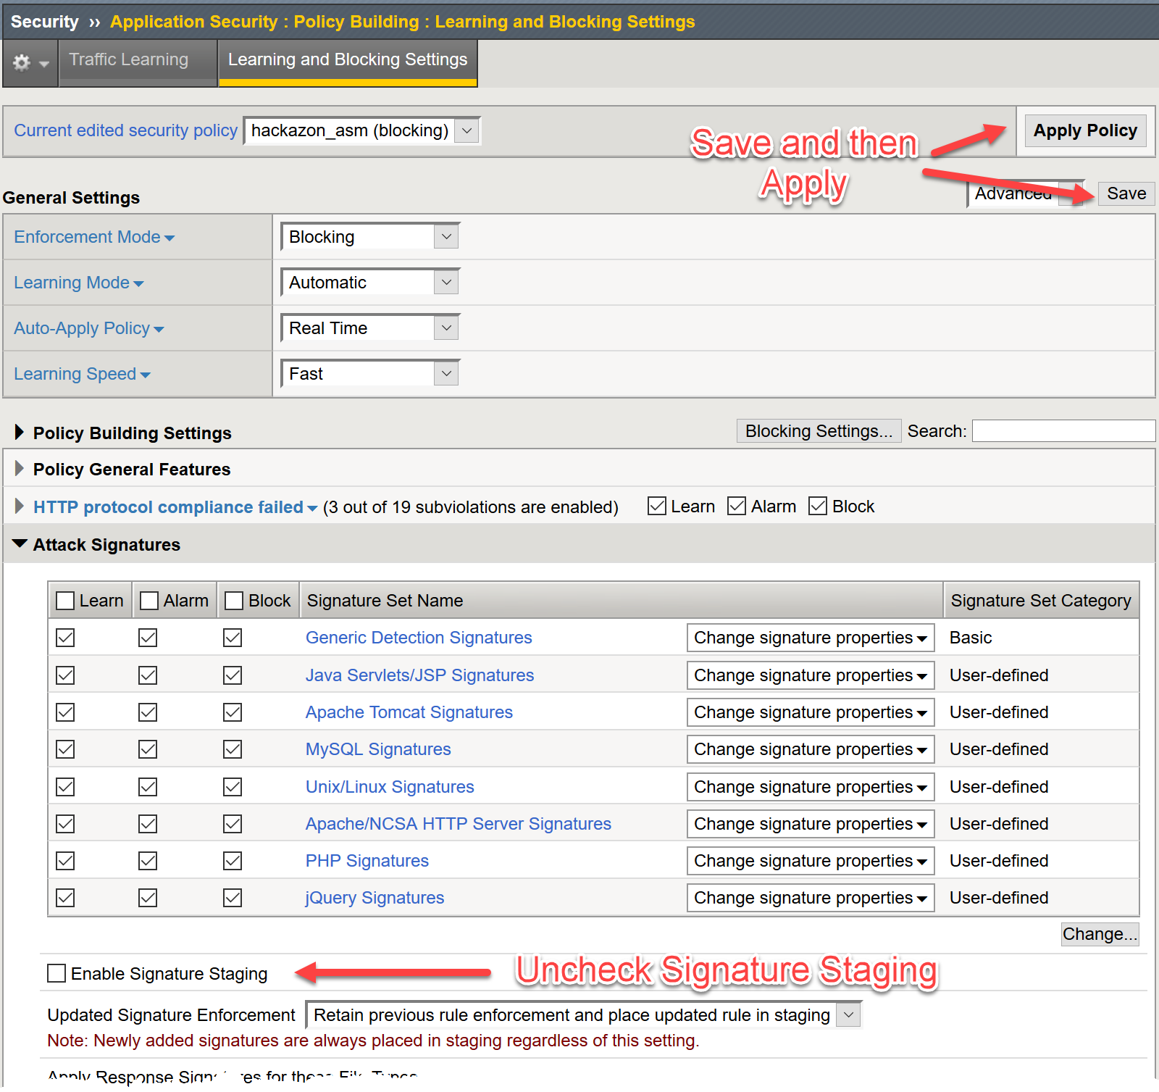

1. Open a new browser window to the auction site and repeat the SQL Injection attack **ZAP' AND '1'='1'** in the Username field of the login form). You will notice that the attack does not get blocked, however; the attack signature is still detected in the Event Log. The reason for this is that the **username** parameter is also in staging. Open **Security->Application Security->Parameters->Parameters List.** You will see that the username parameter is in staging and also has learning suggestions:

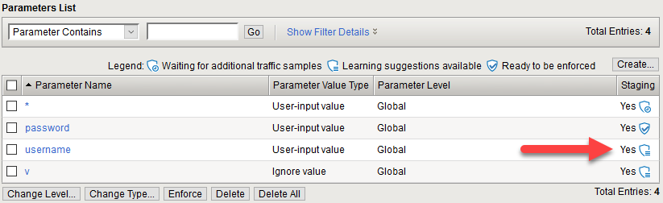

1. Click on **username** and uncheck the box for **Perform Staging** and click **Update**, then **Apply Policy**.

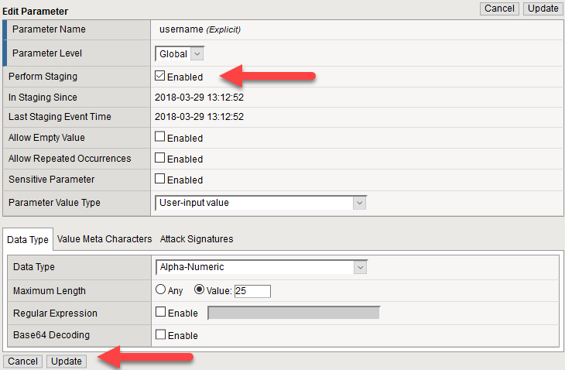

1. Repeat the SQL injection you and you should now see the blocking page

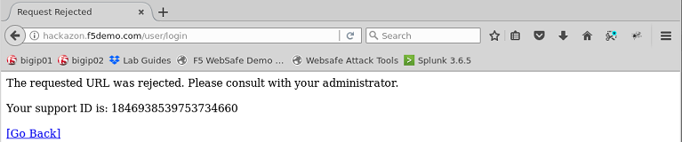

1. Copy the **support ID**. You will use it in a moment.
2. If you go back to the Event Logs and look at Application requests. You will see the request now shows up with the **Illegal Requests** filter on.

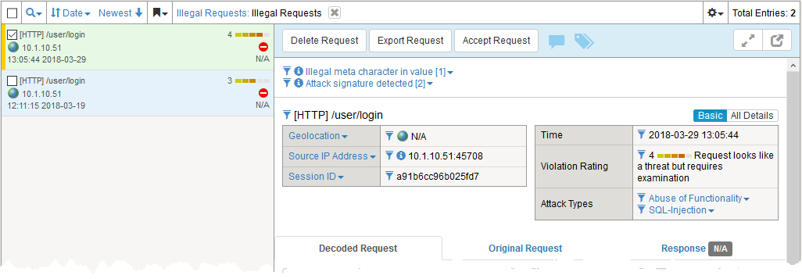

1. Copy the support ID from the ASM Blocking Page. In the Configuration Utility, open the **Security->Event Logs->Application->Requests** and click the **Show Filter Details**. Scroll down to the **Support ID** section and paste the **Support ID** in the empty field then click **Apply Filter**. This should bring up the log entry for the most recent SQL injection that was just blocked. Review the entry and clear the filter.

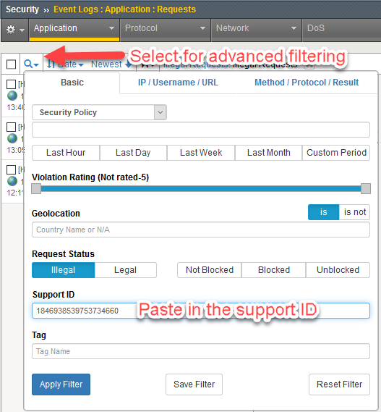

1. Let’s assume the **Username** parameter has been out of staging and enforced for a while. Go to the **Security ›› Application Security : Policy Building : Traffic Learning**. Under the **Enforcement Readiness Summary** in the **Entity** column, select the filter icon to the left of **Parameters**

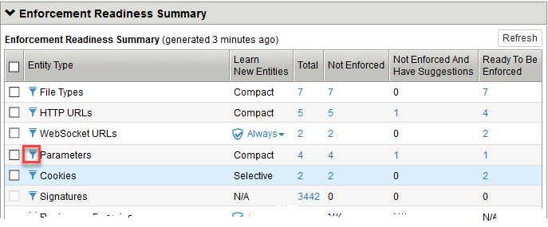

1. Here you will see the **Attack Signature detected** violations for the **Parameter: username**. Click on the **Accept Suggestion** button. At this point you can accept the suggestion outright or accept the suggestion AND place the parameter back into staging mode while you determine if the request was legitimate or not.

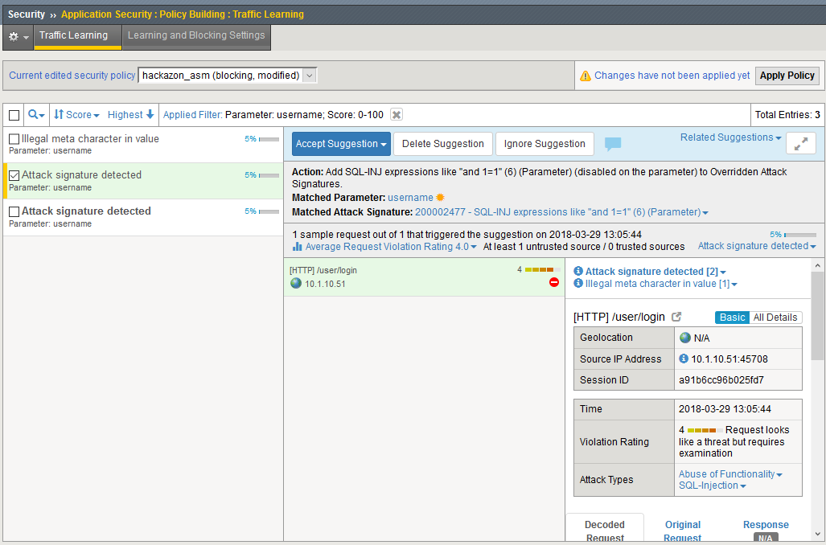

Select Accept suggestion and enable staging on matched parameter and go back to the parameter list. You will see that **username** is back in staging mode and it you hovered over the icon you can see when staging began.

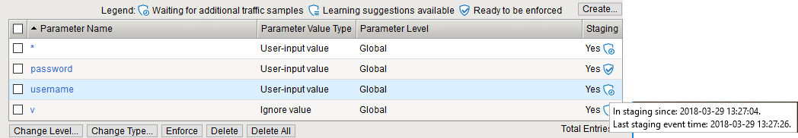

This completes the ASM Policy Building Lab Section

Exercise 3 - Mitigating BoT Attacks

Mitigating Bots using a Bot profile (v14.1)

Objectives:

* Set up a Dos Profile using the “Balanced” profile as the profile template.
* Create a BoT logging profile.
* Attack the site using BoTs (curl, ab, OWASP Zap)
* Review the results in the BoT Dashboard and logs.
* Estimated time for completion: **15 minutes**

Set up the Bot profile

In version 14.1 Bot protection was separated from the DoS profile and give its own profile. In the section you will configure a BoT protection profile, create a logging profile and attach the Bot profile and logging profile to the virtual server.

You will need to create a new BoT profile before you can configure DoS mitigation.

1. Go to **Security ›› Bot Defense : Bot Defense Profiles** here you can see a number of pre-defined BoT profiles. Select **Create**. Move down the configuration settings on the **Bot Profile Configuration** sidebar.
   1. Note the **Note**. Because we haven’t set up DNS on the BIG-IP, BoT protection will not be able to determine if benign Bots, such as GoogleBots, are being impersonated.
      1. The BIG-IP will do DNS lookups to determine the appropriate IP addressing of certain BoTs.
   2. Under **General Settings** select the **Advanced** menu in the upper right corner.
      1. Profile Name: **app_bot_protection**
      2. Enforcement Mode: **Blocking**
         1. For our purposes we will go straight to Blocking mode
      3. Profile Template: Balanced
         1. Select the **Learn more** link to see the difference in the default profiles.
      4. Enforcement Readiness Period: 0 days
         1. Again to speed up the process

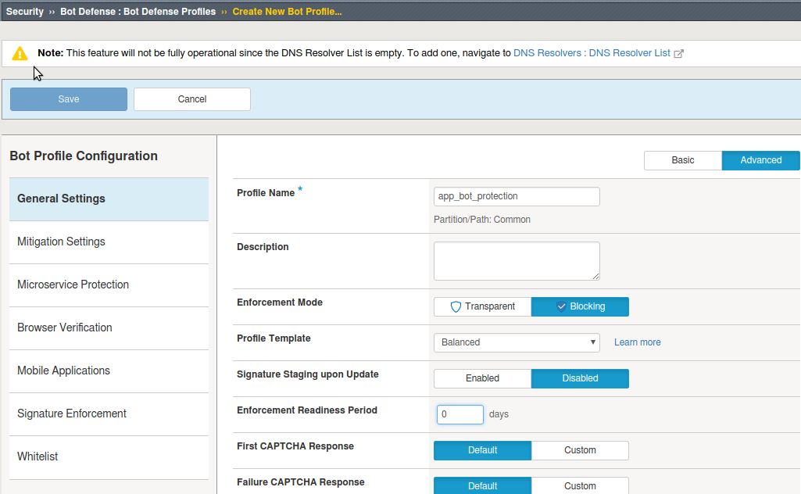

* + 1. Everything else can be left at the defaults, but feel free to review the different option
  1. **Mitigation Settings** can also be left at the current defaults. If you had left the **Enforcement** **Mode** at **Transparent** the mitigation enforcement cases at the bottom would have defaulted to **Disabled**. Click the question marks for more information on the cases.
  2. **Microservice Protection** is left at the defaults.
  3. **Browser Verification** can be left at the defaults. Settings here will determine, if and when we will challenge client browser to determine if it actually a BoT.
  4. **Mobile Applications** can be left at the defaults, but this section works in conjunction with the Anti-Bot mobile SDK to determine if mobile devices have been compromised.
  5. **Signature Enforcement** will be left at default. This allows you more granular and quicker enforcement of BoT signatures.
  6. **Whitelist** will be left at the default.

1. Select **Save** in the upper right corner.

Create a BoT Logging profile

Like with Advance WAF aka ASM you will create a logging profile to capture DoS events.

1. Go to **Security ›› Event Logs : Logging Profiles** and select **Create**. Name your profile **bot_logger**.
   1. You could also modify the **asm_allrequests** logging profile to include BoT logging, but a separate could be used on multiple virtual servers where only BoT protection is required.
   2. Check **Bot Defense** enable box.
      1. In the **DoS Protection** tab enable the **Local Publisher**.
      2. In the **Bot Defense** tab check **ALL** the boxes.
      3. Hit **Create**.

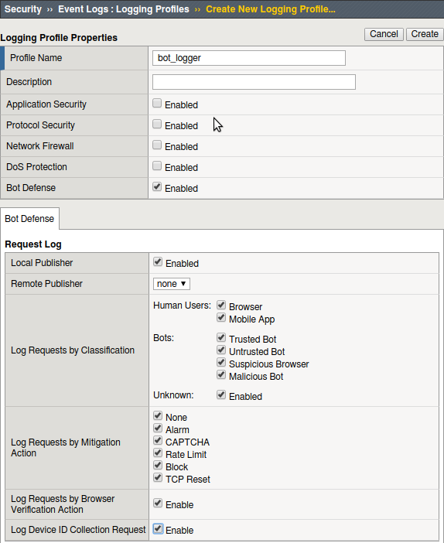

Add the BoT profile to a virtual server

The DOS profile has only Bot Signatures enabled.

1. Go to **Local Traffic > Virtual Servers > Virtual Server List** and select **vs_hackazon_http**. Under the **Security** tab on the top bar select **Policies**.
2. Enable the **BoT Defense Profile** and select the **app_bot_protection** profile.
3. Add **bot_logger** to the **Log Profile**.
4. For purposes of this lab, **Disable** the **Application Security Policy** and remove **asm_allrequests** from the **Log Profile.**

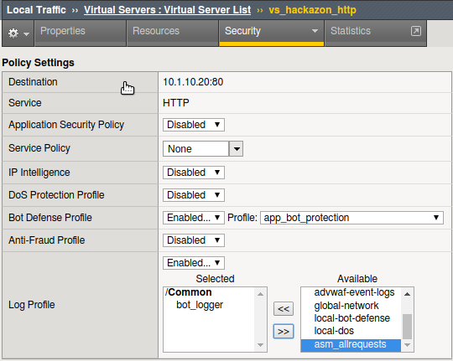

1. Finally, select **Update**.

Attack with BoTs and observe the results

First let’s use an **HTTP Library (Benign)** tool, **curl**. Remember just because tools are in the **Benign** category doesn’t mean they can’t be used for nefarious purposes. Reporting will at allow you to know that these tools are being used against your site.

1. From a terminal window on the jumpbox run the following several times:

curl <http://hackazon.f5demo.com>

In the **Security ›› Event Logs : Bot Defense : Requests** you should see entries similar to this:

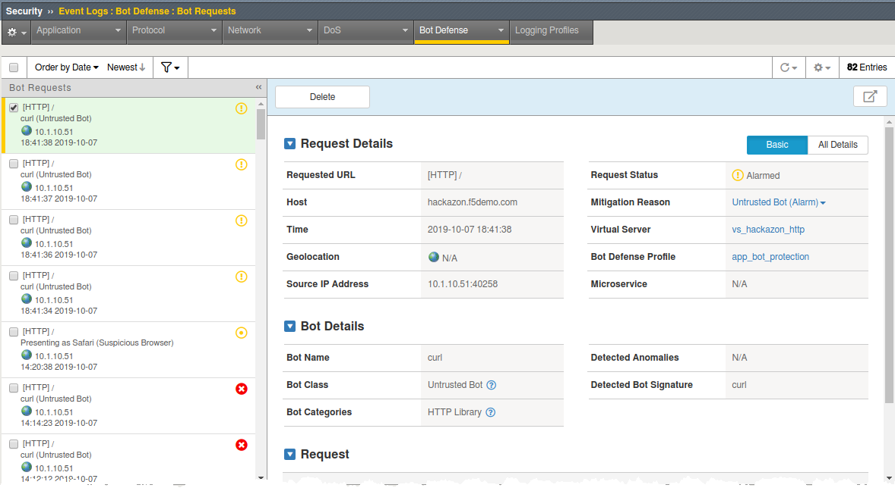

The BoT signature and category are logged and the BoT is allowed because the **Untrusted Bot** category is set to **Alarm** only.

In the **Security ›› Event Logs : Bot Defense : Bot Traffic** screen it may take a few minutes for the data to show up, but you should see something similar to the following:

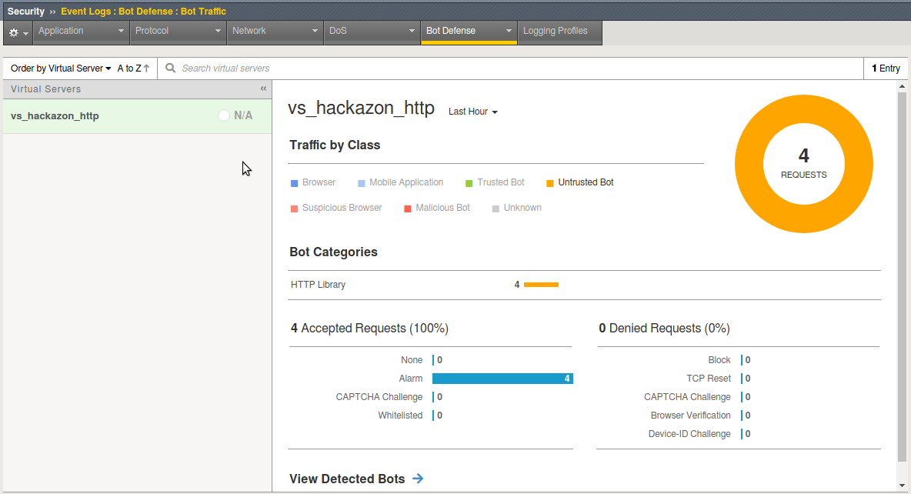

This time we will use the apache bench (ab) BoT from the **DOS Tools (Malicious)** category. The BoT was originally design for benchmark testing but is mostly used for those nefarious purposes I spoke of earlier.

1. From a terminal window on the jumpbox run the following:

ab -c 10 -n 10 -r http://hackazon.f5demo.com/

In the DoS event log you can see this BoT was **Denied** (blocked) by sending a TCP reset immediately to the client.

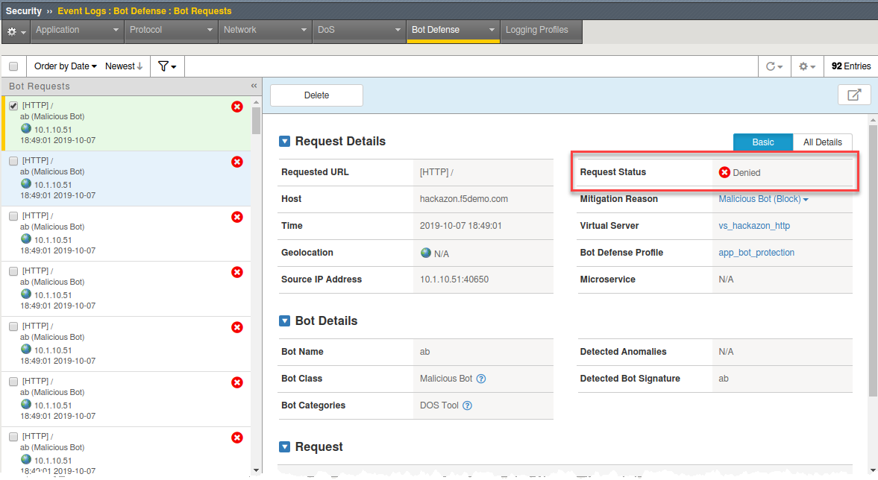

If you go back to the **Bot Traffic** dashboards you will see the new attacks. If you select **View Detected Bots** at the bottom you will get a summary of the incidents.

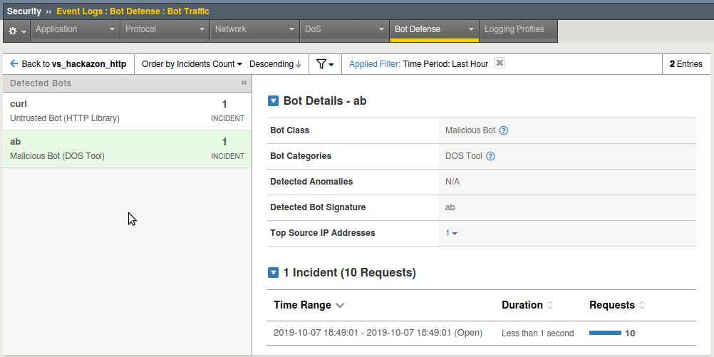

You are now going to use the OWASP ZAP tool to run a spider bot attack against the Hackazon website.

1. From the **Applications Menu** in the upper left-hand corner of the jumpbox go to **OWASP > Proxies > ZAP**.
2. Once ZAP is open, click on **Start** when asked **Do you want to persist the ZAP session**.
3. In the **Quick Start** tab, in the **URL Attack** box, enter <http://hackazon.f5demo.com> and hit the **Attack** button**.**

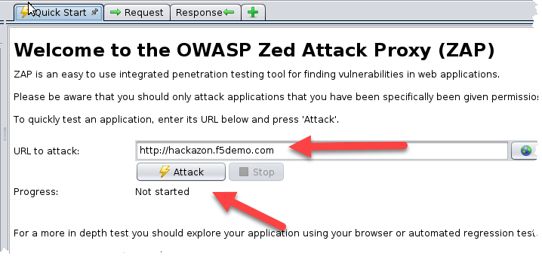

1. Once the attack has started a **Spider** tab should appear in the bottom ZAP window. You will see ZAP attempting to crawl the web site. **T**he attack will be short lived.

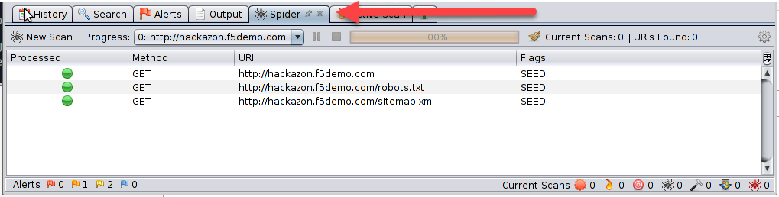

Without Bot protection it would have scan the site.

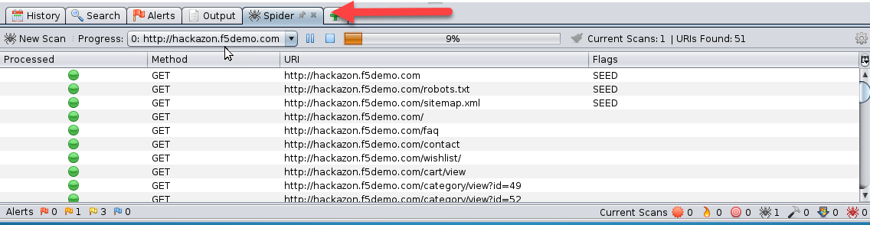

1. Check the Bot Requests you’ll find Non-browser presenting as Internet Explorer request. Go to **All Details** and check out the attack and how BIG-IP detected it.

Now let’s see how BIG-IP challenges Bots that don’t match up to the signatures. We already saw some of this with OWASP Zap, but here you will see the BIG-IP challenge the client to prove it’s not a Bot.

1. Go to Bot Request, find a curl request and look at the **Request** section. In it you will find the User-Agent set to curl/7.52.1

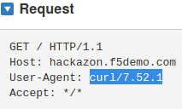

1. That makes it kind of easy to detect, but what if we changed the User-Agent to a legitimate browser. Could the BIG-IP still detect it?
   1. Run the following command from a terminal window:

curl -A "Mozilla/5.0 (iPhone; U; CPU iPhone OS 4_3_3 like Mac OS X; en-us) AppleWebKit/533.17.9 (KHTML, like Gecko) Version/5.0.2 Mobile/8J2 Safari/6533.18.5" http://hackazon.f5demo.com

The resulting request failed, and you can see the obfuscated code and the BIG-IP block page and support ID at the bottom. Even though the signature is allowed, curl cannot meet the javascript challenge (returning ASM cookie, prefixed by TS, with the javascript results) presented it. Check the BoT Request log for the results showing the Bot was challenged and we sent a Captcha.

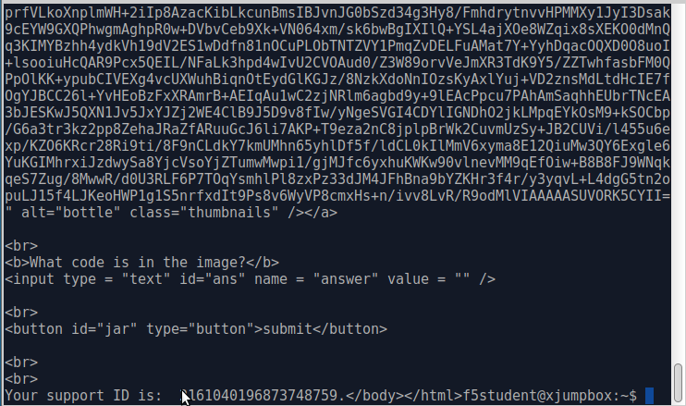

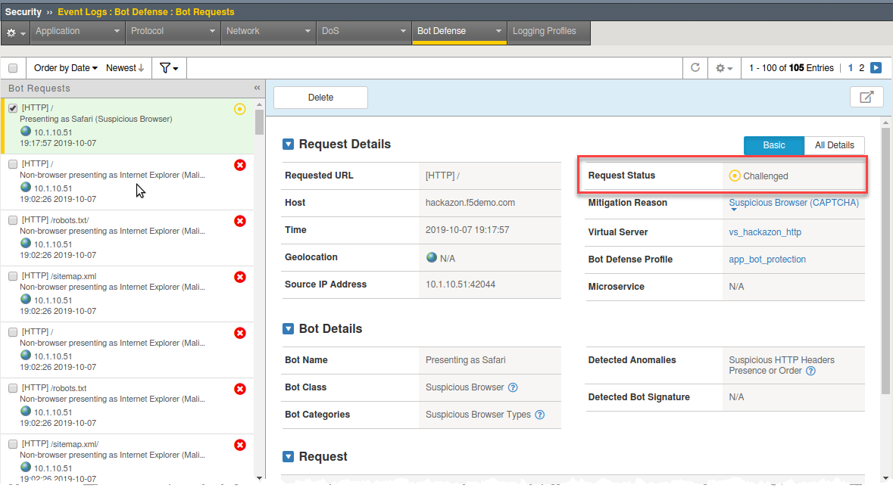

1. On you Bot Traffic dashboard you can see the Browser Masquerading category

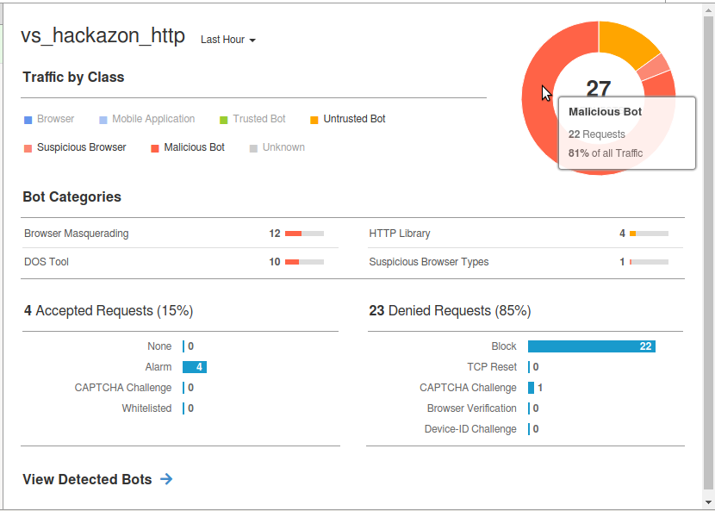

Exercise 4 – Protecting Credentials with DataSafe

Objectives:

* The purpose of this lab is to show the new DataSafe perpetual license in 13.1.
* You will review the login page with and without DataSafe protections.
* You will enable and test encryption, obfuscation, and decoy fields.

Estimated completion time: 45 minutes

Exercise 1 – Review and Attack the Login Page

Task 1 – Review Form Fields with the Developer Tools

* Open Firefox and access [http://hackazon.f5demo.com/user/login.](http://hackazon.f5demo.com/user/login)
* Right-click inside the **Username or Email** field and select **Inspect Element**.

Question:

What is the **name** value for this field?

* Right-click inside the **Password** field and select **Inspect Element**.

Question:

What is the **name** value for this field?

**FOOD FOR THOUGHT:** How difficult would it be for malware to know which fields to grab to steal credentials from this page? How difficult would it be for an attacker to stuff credentials into these fields? They could simply put the stolen username into the “username” field and the stolen password in the “password” field. This is what you did with the Sentry MBA tool earlier in this lab.

Task 2 – Review Methods for Stealing Credentials

* In Firefox click the **FPS Demo Tools** bookmark.

This includes tools that behave like real malware.

* On the login page enter your first name as username and **P@ssw0rd!** as password but do not click **Sign In**.
* From the **Demo Tools** click **Steal Password**, and then click on the password field.

The “malware” is using JavaScript to grab the value of the password field out of the DOM (Document Object Model). This is one way that malware can steal credentials; even before the user has submitted them to the application.

* Click **OK**, then clear the password you entered.
* From the **Demo Tools** click **Start Keylogger**, and then enter the same password from earlier.
* Watch the top of the Demo Tools.



This is another way that malware can steal credentials. The “malware” is using a JavaScript keylogger to log the password as it is typed.

* In the developer tools select the **Network** tab, then click the trash can icon to delete the requests.
* On the login page (with your first name and **P@ssw0rd!** entered) click **Sign In**.

**NOTE:** Your login will fail, but your credentials were still sent to the web server.

* In the **Network** tab select the **/login?return_url=** entry, and then examine the **Params** tab.

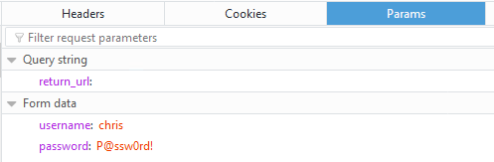

The user’s credentials are visible in clear text. This is another way that malware can steal credentials.

By “grabbing” the POST request and any data sent with it, including username and password.

Task 3 – Perform a Form Field “Web Inject”

* Return to the <http://hackazon.f5demo.com/user/login>page.

**NOTE:** It should NOT have **?return_url=** at the end of the URL in the address bar.

* Right-click inside the **Username or Email** field and select **Inspect Element** again.
* Right-click on the highlighted text and select **Edit as HTML**.

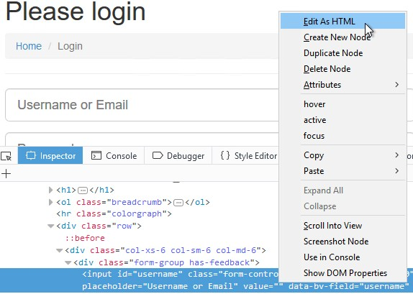

* Select all the text in the window and type **Ctrl+C** to copy the text.
* Click after the end of **type="text">** and type **<br>**, and then press the **Enter** key twice.
* Type **Ctrl+V** to paste the copied text.

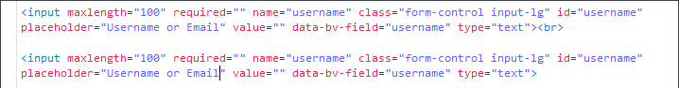

* For the new pasted entry, change the **name**, **id**, and **data-by-field** values to **mobile**, and change the

**placeholder** value to **Mobile Phone Number**.



* Click outside of the edit box and examine the Hackazon login page.

This is an example of the type of “web injects” that malware can perform to collect additional information. This same technique could be used to remove text or form fields. Note that this was done on the client side, in the browser, without any requests being sent to the server. The web application and any security infrastructure protecting it would have no idea this is happening in the browser.

* Close Firefox.

Exercise 2 – Review and Configure DataSafe Components

Task 1 – DataSafe Licensing and Provisioning

* In the Configuration Utility, navigate to **System** and right-click on **License**, and then select **Open Link in New Tab**, and then select the new tab.

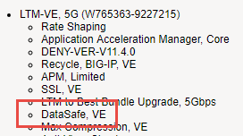

**DataSafe** includes only the Application Layer Encryption (ALE) module of WebSafe. Unlike WebSafe, **DataSafe** is licensed perpetually per device, just like ASM, APM, or any other licensed module.

**DataSafe** is **NOT** included in the Best Bundle.

* Open the **System > Resource Provisioning** page.

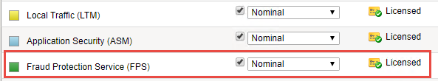

When **DataSafe** is licensed, **Fraud Protection Service (FPS)** will display as **Licensed**. This is different than **WebSafe**, where Fraud Protection Services will show up as N/A.



* Expand the **Security** menu.

There is a **Data Protection** option. This is different than WebSafe where this menu option is

###### Fraud Protection Service. DataSafe

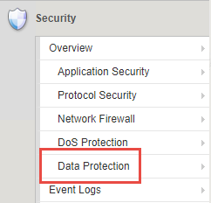

###### WebSafe

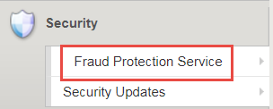

#### Task 2 – DataSafe Configuration

* Open the **Security > Data Protection > DataSafe Profiles** page and click **Create**.
* For **Profile Name** enter **Hackazon-DS**.
* On the left menu click **URL List**, and then click **Add**.

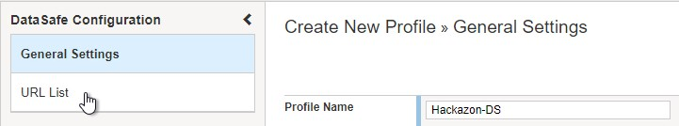

* For **URL Path** leave **Explicit** selected, and type **/user/login**.
* From the left panel open the **Parameters** page.

Remember from earlier you found that the username and password parameter names are **username**

and **password**.

* Create a new parameter named **username**, and then click **Add**.
* Create a second parameter named **password**, and then click **Add**.
* Scroll to the right to view all the parameter options.
* For the **username** parameter select the **Obfuscation** checkbox.
* For the **password** parameter select the **Encrypt**, **Substitute Value**, and **Obfuscate** checkboxes.



* Scroll to the left, and from the left menu open the **Application Layer Encryption** page. Notice that most features are enabled by default.
* Review the explanations for the different features.
* Select the **Add Decoy Inputs** and **Remove Element IDs** checkboxes, and then click **Create**.

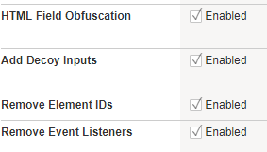

* Open the **Virtual Server List** page and click **vs_hackazon_http**, and then open the virtual server **Security > Policies** page.
* From the **Anti-Fraud Profile** list select **Enabled**.
* From the **Profile** list box, select **Hackazon-DS**, and then click **Update.**

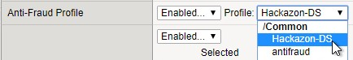

Exercise 3 – Testing DataSafe Protection

Task 1 – Review the Protected Hackazon Login Page

* Open a **private** Firefox window and access <http://hackazon.f5demo.com/user/login>.
* Right-click inside the **Password** field and select **Inspect Element**.

Question:

What is the **name** value for this field?

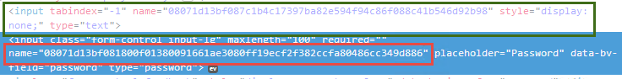

**Obfuscation** - Notice that the name of the password field (outlined in red) is now a long cryptic name and is changing every second. The same is true of the username field.

**Add Decoy Inputs** – Notice that there are other random inputs being added (outlined in green). The number and order of these inputs is changing frequently.

**FOOD FOR THOUGHT:** Considering this obfuscation and you earlier review of the Sentry MBA tool, do you think DataSafe could protect the login page from a credential stuffing tool like Sentry MBA?

* In Firefox click the **FPS Demo Tools** bookmark.
* On the login page enter **P@ssw0rd!** as password but do not click **Sign In**.
* From the **Demo Tools** click **Steal Password**, and then click on the password field.

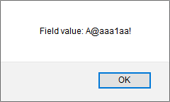

**Substitute Value –** DataSafe is protecting the password field from malware JavaScript grabbing the value of the field from the DOM. Uppercase letters are replaced with “A”, lower case letters are replaced with “a”, and non-alphanumeric characters are replaced with “!”.

* Click **OK**, then clear the password you entered.
* From the **Demo Tools** click **Start Keylogger**, and then begin entering the same password from earlier while watching the demo tools title bar.



**Keylogger Protection** – DataSafe injected java script is injecting fake keystrokes to protect the page from software keyloggers common in some malware.

* Close the FPS Demo Tool.
* In the developer tools window select the **Network** tab, then click the trash can icon to delete any current requests.
* On the login page (with your first name and **P@ssw0rd!** entered) click **Sign In**.
* In the **Network** tab select the **/login?return_url=** entry, and then examine the **Params** tab.

Questions:

What parameters were submitted?

Do you see a username or password field?

Do you see the username you submitted?

**Obfuscation** – DataSafe obfuscates the names of the parameters when they are submitted in a login request.

**Encryption** – DataSafe encrypted the value of the password field so that it is not a readable value in the login request.

These two features together protect sensitive parameters.